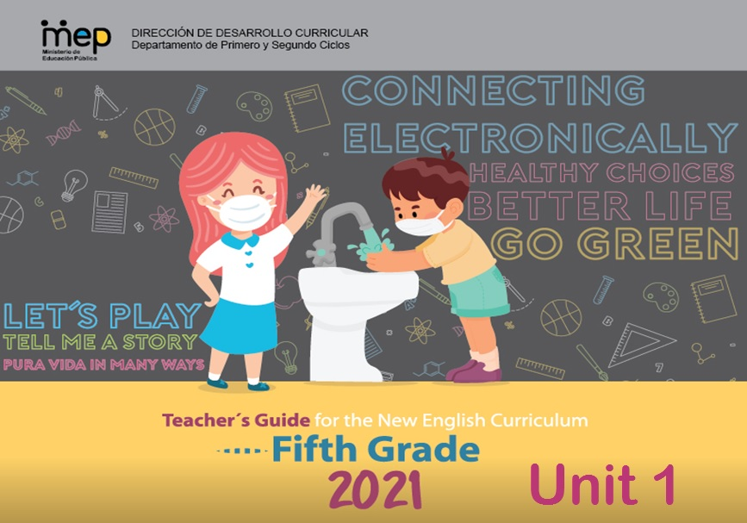

P**resentation**

**Dear teachers**

This is unit 1 of Fifth Grade Teacher´s Guide and have the purpose to provide English teachers of Fifth grade with the guidelines on how to develop effectively the knowledge, skills and abilities set in the new English syllabus. As a result, learners can achieve an expected level of performance in the target language according to the CEFR. We believe that you know your students best and therefore we encourage you **to adapt and contextualized** what you find here so that it responds to the needs and context of your learner. This lesson plan includes in the first page of the planning template, the four dimensions of the new Curricular Policy, “To Educate for a New Citizenship”. The ones mostly emphasized in the unit are identified with an X. These dimensions are embedded and developed in the learning experiences provided. This unit will be completed within a timeline of six weeks.

The unit includes all the steps that should be followed in the pedagogical mediation which are:

A. **Assessment Strategies and Evidences of Learning:** Each goal has a specific assessment indicator for each linguistic competence that requires the elaboration of assessment instruments. Sample models of rubrics are provided

B. **Goals:** Each lesson has specific and clear learning goals connected to a domain, scenario, theme and language function.

C. **Pedagogical Mediation/ Didactic Sequence:** subdivided in the following stages;

✓**Pre-Teaching:** (Warm-up, Activation of Prior Knowledge, Modeling, Clarifying)

✓**Pre-task:** Introductory activity for activation of students’ prior knowledge to carry out a specific task connected to a goal. It places emphasis on the linguistic, cognitive resources needed by the leaner.

✓**Task rehearsal:** Class work where students practice the language in a meaningful way for successful task completion.

✓**Task completion:**  A task that learners perform to demonstrate that the goal has been successfully achieved.

✓**Task assessment:** An activity for reinforcement of the goal. It can also be used for self and/or peer assessment and teacher feedback and/ or repair in relation to the achievement of a goal. Evaluation tools to evaluate performance tasks, of what students know and can do.

D. **Time:** Each phase of the didactic sequence includes a suggestion for the time that may be needed.

E. **Integrated Mini Project:** The project is a creative opportunity for students to integrate knowledge, abilities and skills**.**

F. **Reflective Teaching:** Suggestions for you to assess your own progress in teaching the material.

G. **Enduring Understanding Reflection**: Space to record how students grasped new understandings and ideas in connection with the essential question of the unit.

We hope that this effort will help you to customize your teaching in an effective, creative, engaging, and interactive way in response to your students ‘needs. This unit offers a variety of activities for each phase of the lesson plan; the teacher selects those that are appropriate for achieving the learning goals, the context and learners needs, and the numbers of lesson available for teaching English in the school.

|  |  |  |  |  |
| --- | --- | --- | --- | --- |
| **Level 5th Unit 1**  **Scope and Sequence** | | | | |
| |  | | --- | | **Dimensions** | | **1.** **Ways of thinking ( X  )** | | **2. Ways of living in the world  ( X )** | | **3. Ways of relating with others  ( X )** | | **4. Tools for integrating with the world  ( X )** | | | | | |
| **Scenario: Go Green** | | | | |
| **Enduring Understanding** | Our actions can have a positive or negative chain effect on the environment around us. If we are responsible, we can make the environment better. If we are wasteful, the environment suffers and so do we all. | | | |
| **Essential  Question** | How do our actions affect the environment around us? | | | |
| **Assessment and Goals** | | | | |
| **Week 1** | **Week 2** | **Week 3** | **Week 4** | **Week 5** |
| **Theme**  1. Our Environment: Making the Connection | **Theme**  2. Actions that Harm the Environment | **Theme**  3. Protecting my Planet | **Theme**  4. Solving Environmental Problems |  |
| **Assessment:**  **L.1**. Recognizes isolated, familiar words and phrases when listening to clear, slow, and basic text with slow clear pronunciation.  **SI.2.** Asks for clarification of unknown words and expressions  **SP.1.** Talks about a familiar theme in a short presentation, prepared in advance  **R.PA.1.** Reads words and sentences by decoding English graphemes and phonemes using knowledge of word parts, syllabification and phonemic awareness.  **Goals:**  **L1.** understand isolated, familiar words and phrases when listening to clear, slow, and basic text being read aloud.  **SI.2.** ask for clarification of unknown words and expressions  **SP.1.** talk about a familiar theme in a short presentation, prepared in advance  **R.PA. 1.** decode English graphemes and phonemes using knowledge of word parts, syllabification and phonemic awareness. | **Assessment:**  **L.2**. Recognizes phrases and high frequency vocabulary related to theme by selecting them from texts/ word/phrase banks.  **R.2.** Follows a set of clear-cut instructions, especially if there are pictures or diagrams to illustrate the most important steps.  **SP.1.** Talks about a familiar theme in a short presentation, prepared in advance  **R.PA.1.** Reads words and sentences by decoding English graphemes and phonemes using knowledge of word parts, syllabification and phonemic awareness.  **Goals:**  **L2.** understand phrases and high frequency vocabulary related to areas of personal interest.  **R.2**. follow a set of clear-cut instructions, especially if there are pictures or diagrams to illustrate the most important steps.  **SP.1.** talk about a familiar theme in a short presentation, prepared in advance  **R.PA. 1.** decode English graphemes and phonemes using knowledge of word parts, syllabification and phonemic awareness. | **Assessment:**  **SI.1.** Indicates strengths and weaknesses of personal or human actions on the environment.  **R.PA.1.** Reads words and sentences by decoding English graphemes and phonemes using knowledge of word parts, syllabification and phonemic awareness.  **W.1.** Labels charts, diagrams, and maps.  **Goals:**  **SI.1.** indicate strengths and weaknesses related to the theme and language function.  **R.PA. 1.** decode English graphemes and phonemes using knowledge of word parts, syllabification and phonemic awareness.  **W.1.** label charts, diagrams, and maps. | **Assessment:**  **SI.1.** Indicates strengths and weaknesses of personal or human actions on the environment.  **R.PA.1.** Reads words and sentences by decoding English graphemes and phonemes using knowledge of word parts, syllabification and phonemic awareness.  **W.2.** Applies conventions of standard English when writing short texts.  **Goals:**  **SI.1.** indicate strengths and weaknesses related to the theme and language function.  **R.PA. 1.** decode English graphemes and phonemes using knowledge of word parts, syllabification and phonemic awareness.  **W.2.** apply conventions of standard English | **Assessment**  **Instruments for Process/Product**  **Week 6**  **Suggested Integrated Mini project** |
| **Function**   * Describing nature at local, national and global level * Asking for and giving information | **Function**   * Describing environmental problems at local, national and global level | **Function**   * Giving advice for protecting the environment | **Function**   * Describing ways to solve environmental problems |
| **Discourse Markers**  Linkers: Sequential - past tense  First, then, after that, finally | **Discourse Markers**  Linkers: Sequential - past tense  First, then, after that, finally | **Discourse Markers**  Linkers: Sequential - past tense  First, then, after that, finally | **Discourse Markers**  Linkers: Sequential - past tense  First, then, after that, finally |
| **Grammar & Sentence Frames**  Present Simple   * A dry forest has ____. * In the cloud forest there are __. * Some examples of fauna are __   Information questions with “to be” and “can”  1. What type of animals and plants can you find in the rainforest?  2. How can we preserve our forests and animals?  3. Why the conservation of the environment is so important? | **Grammar &Sentence Frames**    First Conditional   * If I/we (throw) pesticides into rivers (fish) will die. | **Grammar & Sentence Frames**  Modal Can   * I can ___ (save) money for _____ (recycling). * I can ____ (plant) trees to enhance reforestation. * We can use _____ (boxes) instead of using ___ (plastic) bags.   Modal “have to”   * I have to protect my environment. * We have to separate garbage. | **Grammar & Sentence Frames**  Modal Should   * We should/shouldn´t ____ * I should/n´t _____. |
| **Phonemic Awareness**  Long Vowel sounds:  **/ay/ /ey / /i/ /u/ (e.g., kite, buy, made, cake, save, tree, use, do, etc.)** | **Phonemic Awareness**  Long Vowel sounds:  **/ay/ /ey / /i/ /u/ (e.g., kite, buy, made, cake, save, tree, use, do, etc.)** | **Phonemic Awareness**  Segmenting multi-syllabic words into syllables.  (/but/ter/fly/, gar/bage/) | **Phonemic Awareness**  Segmenting multi-syllabic words into syllables.  (/but/ter/fly/, gar/bage/) |
| **Vocabulary**  (Including but not limited to)   1. Our environment: Making the Connection   Environmental terms  Climate, plants, animals, forest, energy, habitat  Information questions   * What type of animals and plants can you find in the rainforest? * Why the conservation of the environment is so important? | **Vocabulary**  2. Actions that Harm my Environment  -What human actions do harm/damage the planet?  Actions against the environment   * cut down forest * use of chemicals and pesticides * throw garbage in rivers * pollute water and the air * kill the animals * destroy mother nature * If I/we (throw) pesticides into rivers (fish) will die. | **Vocabulary**  3. Protecting my Planet  How can I save the planet?  Actions to help the environment  -Recycle, reuse,  reduce, plant trees, go organic, walk /cycle, save water, use clean power, avoid buying plastic bags, classify garbage | **Vocabulary**  4. Solving Environmental Problems  Problems  Littering, energy misuse, water misuse  Actions  Planting, reusing,  recycling  Expressions   * We___ (classify) garbage. * We ___ (plant)trees   We should not waste ____ (water and energy). |
| **Psycho-social**   * Respecting the environment * Cooperating among classmates   **Sociocultural**   * Taking care of Mother Earth * Conserving the protected areas in our country   **Idioms/phrases**  Answer the call of nature (If you answer the call of nature, you need to go to the toilet) | **Psycho-social**   * Respecting the environment * Cooperating among classmates   **Sociocultural**   * Taking care of Mother Earth * Conserving the protected areas in our country   **Idioms/phrases**  Down to earth (If you are down to earth, you are practical and sensible) | **Psycho-social**   * Respecting the environment * Cooperating among classmates   **Sociocultural**   * Taking care of Mother Earth * Conserving the protected areas in our country   **Idioms/phrases**  To built castles in the air (Plans that are unlikely to happen) | **Psycho-social**   * Developing creativity, collaboration critical thinking and communication skills   **Sociocultural**   * Taking care of Mother Earth * Conserving the protected areas in our country   **Idioms/phrases**  Out of the woods (out of danger) |  |

|  |  |  |  |  |  |  |  |  |  |
| --- | --- | --- | --- | --- | --- | --- | --- | --- | --- |
| **Term:** | | **Level: Fifth Grade** | | | **Unit:** | | | **Week:1** | |
| **Domain: Socio-interpersonal** | | | | **Scenario:** Go Green | | **Theme:**  1. Our Environment: Making the Connection | | | |
| **Enduring Understanding**: Our actions can have a positive or negative chain effect on the environment around us. If we are responsible, we can make the environment better. If we are wasteful, the environment suffers and so do we all. | | | | | | | | | |
| **Essential Question:** How do our actions affect the environment around us? | | | | | | | | | |
| |  | | --- | | **Dimensions** | | **1.** **Ways of thinking (   )** | | **2. Ways of living in the world  ( )** | | **3. Ways of relating with others  ( )** | | **4. Tools for integrating with the world  ( )** | | | | | | | | | | |
| **Learn to Know** | | | | **Learn to Do** | | **Learn to Be and Live in Community** | | | |
| **Grammar & Sentence Frames**  Present Simple   * A dry forest has ____. * In the cloud forest there are __. * Some examples of fauna are __   Information questions with “to be” and “can”  1. What type of animals and plants can you find in the rainforest?  2. How can we preserve our forests and animals?  3. Why the conservation of the environment is so important?  **Phonemic Awareness**  Long Vowel sounds:  **/ay/ /ey / /i/ /u/ (e.g., kite, buy, made, cake, save, tree, use, do, etc.)**  **Vocabulary**  (Including but not limited to)   1. Our environment: Making the Connection   Environmental terms  Climate, plants, animals, forest, energy, habitat  Information questions   * What type of animals and plants can you find in the rainforest? * Why the conservation of the environment is so important? | | | | **Function**  **Function**   * Describing nature at local, national and global level * Asking for and giving information   **Discourse Markers**  Linkers: Sequential - past tense  First, then, after that, finally | | **Psycho-social**  **Psycho-social**   * Respecting the environment * Cooperating among classmates   **Sociocultural**   * Taking care of Mother Earth * Conserving the protected areas in our country   **idioms/ phrases**  Out of the woods (out of danger) | | | |
| **Assessment Strategies & Evidences of learning**  (Diagnostic, formative, summative) | **Goals** | | | **Pedagogical Mediation/ Didactic Sequence** | | | | | **Time** |
| Learner… | Learner can | | | **Pre-teaching**  Share the Essential Question on the board and Goal (Can do´s) of the class  **Warm up**  **Connecting**  Students listen to the song: Rainforest rap song and or Anthem for the Amazon song and sing it with the teacher. The teacher facilities the lyrics. ( Annex 1)  **<https://www.youtube.com/watch?v=ZOgApjGFmnU>**  [**https://www.youtube.com/watch?v=ZKumZJPClec**](https://www.youtube.com/watch?v=ZKumZJPClec)  **Activation of Prior Knowledge**  Students will name and guess the name of some of the plants, animals and places they saw in the video to activate their prior knowledge.  **Teacher asks students:**  What do you think is the song about?  What do you think is the message?  What did you like the most?  Teacher gets students prepared and interested in the topic and participate actively with the question: How do our actions affect the environment around us?  **Modeling**  Students watch a video about the rainforest.  <https://www.youtube.com/watch?v=3vijLre760w>  Teacher asks students: What is a rainforest? Why is the rainforest important for the environment and necessary to keep life in the planet? As they watch it, students recall and pronounce the names of animals, plants and natural sceneries they see in the video.  Teacher introduces new vocabulary, sentence frames and models pronunciation for students.  The rain forest has…. (trees, rivers, waterfalls)  In the rainforest, there are…. (plants, mammals, birds and insects)  Some examples of fauna are: tigers, jaguars, snakes and monkeys.  **Clarification**  **Clarifying**  Students read with the support of the teacher sentences supported with pictures to describe the flora and fauna of the rainforest.  Teacher asks questions like: Is a jaguar a mammal, and insect or a bird?  Tell me which of the following animals do not belong to the rainforest?  (penguin, hummingbird, snake) | | | | | 40 minutes |
| **L.1**. Recognizes isolated, familiar words and phrases when listening to clear, slow, and basic text with slow clear pronunciation.  Identifies familiar words, phrases and main ideas related with the rain forest when listening to clear, slow, and basic text being read aloud. | **L1.** understand isolated, familiar words and phrases when listening to clear, slow, and basic text being read aloud. | | | **Connecting**  **Pre-task**  Teacher shares the goal of the lesson.  Teacher using pictures reviews again sentence frames and vocabulary used to describe the rainforest. Then teacher poses the 2 following questions:   * What type of animals and plants can you find in the rainforest? * Why the conservation of the environment is so important? Teacher let students to brainstorm some ideas in pairs and with the whole group.   Students are going to make a graphic organizer or spider web to present the ideas brainstormed.  **Clarification**  **Task-rehearsal**  Students are going to listen to the following video about the rainforest and answer some questions. The questions are reviewed and clarified before listening.  <https://www.youtube.com/watch?v=3vijLre760w>  Students listen for the first time and take notes. During second listening they answer the following first 5 questions:   1. What animals and plants are familiar to you? 2. How old are the rainforests? 3. How different is the tropical rainforest from the temperate one? 4. How much rain can fall in the rainforest? 5. What amount of the total of animals and plant species can live in the rainforest?   The answers of the first 4 questions are checked. Teacher provides feedback.  **Application/ building up**  **Task completion**  Students listen to the video for the second time at a deeper level and take notes. They answer the following 4 questions   1. Why are rainforests so important for medical science? 2. What are 3 other benefits of the rainforest for the life in the planet? 3. What is causing deforestation of the rainforest? 4. How can deforestation be stopped?   **Collaboration**  The answers of the second 4 questions are checked first in pairs or small groups. They students listen to the video for the last time for confirmation of their answers. Teacher provides feedback.  **Task assessment**  Question/answer Game. Students play a game. They are divided in small groups. The teacher asks questions related to the information in the video or shows pictures related to the information in the video. The group that can answer most of the questions is the winner. | | | | | 40 minutes |
| **SI.2.** Asks for clarification of unknown words and expressions | **SI.2.** ask for clarification of unknown words and expressions | | | **Connecting**  **Pre-task**  Teacher shares the goal of the lesson.  Students with the help of the teacher brainstorm forms studied before for asking for clarification of vocabulary like the following:  Excuse me? Pardon me?  I don’t understand  Teacher introduces and explains with examples other forms to ask for clarification of unknown words or phrases in English, for example:  Student: Excuse me, teacher what is the meaning of the word, rainforest?  Teacher/ students: it is an area with many trees, plants and animals living all together. It has a very rich biodiversity.  Student: Excuse me, what is the meaning of the word, snake?  Teacher/ partner: It means________________.  A snake is a long, limbless reptile. It can be poisonous.  Teacher models the pronunciation of sentence frames and provides all required clarification.  **Clarification**  **Task-rehearsal**  Students read and sing the rainforest rap song while identify and write at least five words or phrases they do not know and would like to know the meaning. They will walk around the class and ask some of their partner using the sentence frame:  A:Excuse me, what is the meaning of the word____________? B: It means______.  As he gets an answer, s/he will say “thanks a lot”.  **Application/building up**  **Task completion**  After listening to the song, Anthem to the Amazon, the students will be asking clarification questions to the teacher or partners about words and phrases they do not understand the meaning using the appropriate sentence frame. Students can support their answers using a virtual searching tool like google.  **Task assessment**  Students will play a memory game matching pictures with vocabulary related with the rainforest. When they do not know the meaning of the word. They will ask a partner or teacher for the clarification of the word’s meaning. ( **Look at the annex N.2**) (**Collaboration)** | | | | | 40 minutes |
| **SP.1.** Talks about a familiar theme in a short presentation, prepared in advance | **SP.1.** talk about a familiar theme in a short presentation, prepared in advance | | | **Connecting**  **Pre-task**  Teacher shares the goal of the lesson.  Students in pairs or groups of three are going to go back to the graphic organizer or spider web they created before to brainstorm their ideas about the animals and plants they can find in the rainforest and why its conservation is important.  In the rainforest we can find animals like…. ( monkeys, butterflies, tapirs).  We can also see birds like scarlet macaws and toucans.  Students will discuss in pairs or groups of three more about ways to preserve the rainforest. They will record their thoughts in the graphic organizer below.  They can use the following sentence frames and vocabulary below for the discussion.  I think that three ways to protect the rainforest are the following:  1. Preserving the trees and the animals.  2.Avoiding making fires.  3.Keeping the water clean.  I think that three ways to preserve the rainforest are the following:  1.  2.  3.  **Clarifying**  **Task-rehearsal**  After completing, the graphic organizers students individually explain in oral form their ideas using pictures to a partner or a family member.   1. What type of animals and plants can you find in the rainforest?   In the rainforest, we can see many animals like….. There are also many birds like….   1. How can we preserve our forests and animals?   For preserving the rainforest, we have to keep the trees. We have to …  3. Why the conservation of the rainforest is so important?  It is very important because the rainforest gives us many things like…..  During this talk, they have to:  Greet the audience, for example, “hello, everyone”  Introduce themselves , for example: I am … My name is…  Introduce the topic, for example, I am going to talk about…  **Application/building up**  **Task completion**  Students individually select their favorite animal from the rainforest. They will use the following organizer of their thoughts to make a short talk.  During this talk, they have to:  Greet the audience, for example, “hello, everyone”  Introduce themselves , for example: I am … My name is…  Introduce the topic, for example, I am going to talk about…   |  |  | | --- | --- | | Image of the animal | Introduction  This is a….  It is my favorite rainforest animal/ bird. | | Appearance | It is…  It has… | | Habitat | It lives in | | Diet | It eats…. | | Interesting facts |  |     Students get feedback from partners, teachers or family members at the end of the talk. (**Collaboration)**  **Task assessment**  Students create three pictures or drawings. One describes the flora and fauna found in the rainforest. The second one describes ways to preserve the rainforest. The third one explains the reasons for protecting the rainforest. Students are divided in small groups. They have to select randomly one of the three cards and describe its meaning.They work collaboratively. **( collaboration**) | | | | | 40 minutes |
| **R.PA.1.** Reads words and sentences by decoding English graphemes and phonemes using knowledge of word parts, syllabification and phonemic awareness.  Identifies long vowel sound /ai/ in different types of spellings of words.  Reads words that contain long vowel /ai/ | **R.PA. 1.** decode English graphemes and phonemes using knowledge of word parts, syllabification and phonemic awareness. | | | **Connecting**  **Pre-task**  Teacher shares the goal of the lesson.  Teacher shows a list of words for the students to pronounce. Can you identify which ones have a long vowel?   |  |  |  | | --- | --- | --- | | **Tiger** | **hill** | **ten** | | **whale** | **mice** | **snake** |   Teacher explains that they will review long vowels in English focusing on vowel sound / /ai/ with spellings / i/ and /ine/  <https://www.youtube.com/watch?v=d7o61e_8OEY>  <https://www.youtube.com/watch?v=yCnTJd2O9So&list=PLDrTATEEK78zX9u2x4j8Gomevfg7km5wc>  After students watch the following video and identify the words and spellings that contain the long vowel sound /ai/  https://www.youtube.com/watch?v=4Puv-pjUb0I  Teacher clarifies by posing questions to students like what is the pronunciation of this word:  Pine, mine, mice, size, ice, eyes…  **(clarification)**  **Task-rehearsal**  Students practice pronouncing long vowel /ai/, blending and matching pictures with words and different spellings.    Students identify the long vowel /ei/ in the following words after being pronounced, first by themselves, then heard and pronounced by the teacher.  **Application/building up**  **Task completion**  Students pronounce the words and select by circling the one that has the long vowel /ai/. They check their answers in pairs. **(Collaboration)**    **Task assessment**  Students say the words and circle the picture that represents the word.    Students get feedback from teacher and partners. . **(Collaboration)**  **Student self-assessment grid**   |  |  |  |  | | --- | --- | --- | --- | | **Level of achievement** | | | | | **Assessment Indicators**  **I can ..** | **Not achieved yet**  ***C:\Users\mcastilloh\Downloads\descarga.jpg*** | **In progress**  ***C:\Users\mcastilloh\Downloads\Grinning-Face-with-Smiling-Eyes.png*** | **Achieved**  ***Resultado de imagen para happy emoji*** | | 1.identify familiar words, phrases and main ideas related with the rain forest when listening to clear, slow, and basic text being read aloud. |  |  |  | | 2.ask for clarification of unknown words and expressions |  |  |  | | **3.** talk about a familiar theme in a short presentation, prepared in advance |  |  |  | | 4.1.dentifylong vowel sound /ai/ in different types of spellings of words.  **4.2.** Read words that contain long vowel /ai/ |  |  |  | | | | | | 40 minutes |
| **Integrated Mini-Project** | | | | | | | | | **Time** |
| Phase: _______ | | | | | | | | |  |
| **Reflective Teaching** | | | | | | | | | |
| What worked well | | | What didn’t work well | | | | How to improve | | |
| **Enduring Understanding Reflection** | | | | | | | | | |
|  | | | | | | | | | |

**Annex 1. Lyrics Anthem for the Amazon**

Final Lyrics

Anthem for the Amazon

Date: Nov. 6, 2014

Verse 1:

Do you believe she connects everything?

The brightest skies, the birds and trees

Her breath it is what keeps us alive

And now she’s hurting can you help us make her stronger?

First Pre-Chorus:

We gotta care for the world we see

She’s gotta breathe

We gotta take responsibility

She's gotta breathe

Chorus:

Breathing life into our world

(World)

(World)

Breathing life into our world

(World)

(World)

What will we/you see in just a few years?

Each and everyday nature disappears

Beyond the mountains the air is heavy

The pressure’s growing and we can’t wait any longer

Now she's hurting and we gotta make her stronger

Second Pre-Chorus:

We gotta care for the world we see

She’s gotta breathe

She's so precious we all have to believe

She's gotta breathe

Breathing life into our

Chorus:

Breathing life into our world

(World)

(World)

Breathing life into our world

(World)

(World)

Post Chorus:

Open up your heart now and give

What you wanna give

Planting the seeds of the world

REVISED RAP FOR KIDS:

Rapper #1: What do you think about all this destruction?

Rapper #2: I don’t know does it even effect me?

Rapper #1: I know it's hard to believe that cuttin' down tree effects the water and the air that we

breathe

Rapper #2: But when I look around everything looks fine?

Rapper #1: You may think so but it's just a matter of time that there is no solution for the

pollution, overusing, abusing the natural resources that we're losin'.

RAP AFTER SPANISH RAPPER:

Imagine a world with clean air (World)

Ozone gap close up we don’t fear (World)

She brings life to all things

You and me see we gotta believe

Each one of us yeah we can make a change

No need to point fingers no need to point blame

One seed

One tree

One life

Breathe

**Annex 2. Match the names of the animals with their picture. Use the question form.**

Excuse me, what is the meaning of the word:___________?

It means____________________.

|  |  |
| --- | --- |
| 1. | Scarlet macaw |
| 2. | snake |
| 3. | sloth |
| 4. | tapir |

|  |  |  |  |  |  |  |  |  |  |
| --- | --- | --- | --- | --- | --- | --- | --- | --- | --- |
| **Term:** | | **Level: Fifth Grade** | | | **Unit:** | | | **Week:2** | |
| **Domain: Socio-interpersonal** | | | | **Scenario: Go Green** | | **Theme:**  2. Actions that Harm the Environment | | | |
| **Enduring Understanding**: Our actions can have a positive or negative chain effect on the environment around us. If we are responsible, we can make the environment better. If we are wasteful, the environment suffers and so do we all. | | | | | | | | | |
| **Essential Question:** How do our actions affect the environment around us? | | | | | | | | | |
| |  | | --- | | **Dimensions** | | **1.** **Ways of thinking (   )** | | **2. Ways of living in the world  ( )** | | **3. Ways of relating with others  ( )** | | **4. Tools for integrating with the world  ( )** | | | | | | | | | | |
| **Learn to Know** | | | | **Learn to Do** | | **Learn to Be and Live in Community** | | | |
| **Grammar & Sentence Frames**  First Conditional   * If I/we (throw) pesticides into rivers (fish) will die.   **Phonemic Awareness**  Long Vowel sounds:  **/ay/ /ey / /i/ /u/ (e.g., kite, buy, made, cake, save, tree, use, do, etc.)**  **Vocabulary**  2. Actions that Harm my Environment  -What human actions do harm/damage the planet?  Actions against the environment   * cut down forest * use of chemicals and pesticides * throw garbage in rivers * pollute water and the air * kill the animals * destroy mother nature * If I/we (throw) pesticides into rivers (fish) will die. | | | | **Function**  Describing environmental problems at local, national and global level  **Discourse Markers**  Linkers: Sequential - past tense  First, then, after that, finally | | **Psycho-social**   * Respecting the environment * Cooperating among classmates   **Sociocultural**   * Taking care of Mother Earth * Conserving the protected areas in our country   **idioms/ phrases**  To built castles in the air (Plans that are unlikely to happen) | | | |
| **Assessment Strategies & Evidences of learning**  (Diagnostic, formative, summative) | **Goals** | | | **Pedagogical Mediation/ Didactic Sequence** | | | | | **Time** |
| Learner… | Learner can | | | **Pre-teaching**  Share the Essential Question on the board and Goal (Can do´s) of the class  **Connecting**  **Warm up**  Students unscramble the following words and guess their meaning.    **Activation of Prior Knowledge**  Brain storming: What are the main factors that affect the environment in your community?  Let’s listen to the following video and identify the ten most common problems that affect the world. Are they similar or different from the ones in your community?  <https://www.youtube.com/watch?v=A0pB1qw8SMs>  Teacher and students discuss some of the ideas collected.  **Modeling**  After listening to the video and teacher presents the following question:  What human actions do harm/damage the planet? Based on the information collected from the video and the discussion students present their ideas. Teacher using pictures from the context of the community or the country introduces the following vocabulary and sentence frames.  Negative Actions against the environment   * cut down forest * use of chemicals and pesticides * throw garbage in rivers * pollute water and the air * kill the animals * destroy mother nature   Teacher then explains that our action on the environment have a positive or negative impact in our lives.  For example: If we plant more trees, we will have cleaner air and more oxygen.  This is a positive action with a positive result.  On the contrary:   * If I/we (throw) pesticides into rivers (fish) will die.   This is a negative action with a negative result.  **Clarification**  **Clarifying**  Teacher presents some possible actions and ask students what are the consequences. Students present their ideas  If we cut down the trees, animals and birds will die.  If we throw pesticides and chemicals in rivers and the sea,…… | | | | | 40 minutes |
| **L.2**. Recognizes phrases and high frequency vocabulary related to theme by selecting them from texts/ word/phrase banks.  Recognizes phrases and high frequency vocabulary related to the environment by selecting them from an audio text. | **L2.** understand phrases and high frequency vocabulary related to areas of personal interest. | | | **Connecting**  **Pre-task**  Teacher shares the goal of the lesson.  Teacher asks students: do you remember what are high frequency words?   |  | | --- | | High frequency words are those that appear too much in a written text, for example articles, pronouns, prepositions, verbs and nouns. |   Now we are going to call high frequency vocabulary all the one we have emphasize in this unit so far. What vocabulary and phrases do you remember ? Some vocabulary and phrases are for example:  Rainforest, environment, climate, habitat, names of animals, names of plants…   * We can make a change. * Avoid making fires in the forest. * Do not throwing garbage in rivers. * Taking care of mother Earth.   Now I am going to introduce 15 key vocabulary words related with these topic, take notes, and ask questions if you need clarification.  <https://www.youtube.com/watch?v=zo_6cKHS4dk>  Repeat them and practice them with a partner.  **Clarification**  **Task-rehearsal**  Now you are going to listen to a video for the first time and you are going to identify 8 high frequency words related with the environment. The name of the video is. The environment.  <https://www.youtube.com/watch?v=Oa7ntoCf8yU>   |  | | --- | | **My list of high frequency words heard in the video about the environment** | |  |   Share your list with a partner. Teacher provides feedback to students.  **Application/building up**  **Task completion**  Students listen to the video for a second time and identify other 8 frequency words and then share the list with classmates. Teacher provides feedback. . **(Collaboration)**  **Task assessment**  Students match words with definition to clarify meanings. Then using drawings or cut outs from magazines they add up an image to each word definition.   |  |  |  | | --- | --- | --- | |  |  | Insert a picture | | 1. Fussil fuels | A person that takes care of the environment. |  | | 1. Habitat | Use something again with another purpose. For example, using a plastic bottle as a recipient for house decoration. |  | | 1. Sea level | It happens when many trees are cut down. |  | | 1. environmentalist | The specific place where animals live. |  | | 5.pollution | IT is everything you throw away. |  | | 6.garbage | A rise in sea level happens when lots of ice melt because of warmer temperatures. |  | | 7.recycle | It is nonrenewable resource, for example coal and oil. |  | | 8.deforestation | Different ways in which human harm and contaminate the environment. |  |   Student get feedback from each other and work collaboratively. . **(Collaboration)** | | | | | 40 minutes |
| **R.2.** Follows a set of clear-cut instructions, especially if there are pictures or diagrams to illustrate the most important steps. | **R.2**. follow a set of clear-cut instructions, especially if there are pictures or diagrams to illustrate the most important steps. | | | **Connecting**  **Pre-task**  Teacher shares the goal of the lesson.  Teacher explains that in order to keep the environment healthy we have to follow some steps:  When you describe steps you need to use some magic words like:  First, next, then, finally. These magic words help connect the steps. We can also use numbers like, first, second, third, finally.  **Clarification**  **Task-rehearsal**  Students read the following steps to protect the environment for the first time and put them in order as they appear in the video using numbers from 1 to 10.  Video: <https://www.youtube.com/watch?v=YND_rYGLwzE>  ______Use reusable containers  ______Switch to reusable bags  ______Reduce, reuse, recycle  ______Heat and cool smartly  ______Switch to efficient light bulbs.  ______Spread the word: reduce, reuse, recycle  ______Reduce electricity use  ______Switch from paper to digital  ______Plant a tree  ______Preserve the water  **Application/building up**  **Task completion**  Students read the following steps to protect the environment for a second time and match them with the pictures following the sequence of the in the video using numbers from 1 to 10.  ________Use reusable containers  ________Switch to reusable bags  _________Reduce, reuse, recycle  _________ cool smartly  ______Switch to efficient light bulbs.  ______Spread the word: reduce, reuse, recycle  ______Reduce electricity use  ______Switch from paper to digital  ______Plant a tree  ______Preserve the water   |  |  |  |  | | --- | --- | --- | --- | |  |  |  |  | |  |  |  |  | |  |  |  |  |   **Task assessment**  Using the pictures, students retell the most important steps to protect the environment using the connectors, first, second, third… Students work collaboratively and provide feedback to partners when need it. . **(Collaboration)** | | | | | 40 minutes |
| **SP.1.** Talks about a familiar theme in a short presentation, prepared in advance**.**  Talks about human actions and consequences in the environment in a short presentation, prepared in advance**.**  Talks about ways to protect the environment. | **SP.1.** talk about a familiar theme in a short presentation, prepared in advance. | | | **Connecting**  **Pre-task**  Teacher shares the goal of the lesson.  Teacher reviews with students some actions and consequences of humans on the environment, using the examples presented at the beginning of the week.  For example: If we plant more trees, we will have cleaner air and more oxygen.  This is a positive action with a positive result.  On the contrary:   * If I/we (throw) pesticides into rivers (fish) will die.   This is a negative action with a negative result.  **Clarification**  **Task-rehearsal**  Students individually select three actions that can harm the environment. Then they using and **if** sentence say the action, and add another sentence indicating the consequence using the following chart.  **If we…**   |  |  | | --- | --- | | **Action** | **Consequence** | | Cut trees | The forest will disappear | | Throw garbage in rivers | The water of rivers will be polluted | | Pollute the air | The air will be harmful to breathe | | Hunt wild animals | Many animal species will disappear | | Waste water | drinking water will not be available | | Use too much plastic bags | The rivers and seas will be polluted |   **Application/building up**  **Task completion**  Students prepare a short talk about the human actions that are harming the environment and its consequences using if sentences as much as possible. In the conclusion, the learner will present three actions we can do to preserve the environment.   |  |  | | --- | --- | | Greeting | Hello!  Good morning  Good afternoon | | Personal introduction of topic | I am going to talk about… | | Human actions and consequences on the environment | If we cut the trees, animals, birds and plants will die, humans too, | | Three recommendations to conserve the environment | To preserve our Mother Earth, we have to … |   **Task assessment**  Students in pairs will play a game where one person says an action that harms the environment and the partner says the consequence. They can take turns.  A: If I cut trees,  B: Animals and birds will disappear. | | | | | 40 minutes |
| **R.PA.1.** Reads words and sentences by decoding English graphemes and phonemes using knowledge of word parts, syllabification and phonemic awareness.  4.1.dentifies long vowel sound /ai/ in different types of spellings of words.  4.2. Reads words with different spellings that contain long vowel /ei/ | **R.PA. 1.** decode English graphemes and phonemes using knowledge of word parts, syllabification and phonemic awareness. | | | **Connecting**  **Pre-task**  Teacher shares the goal of the lesson.  Teacher shows a list of words for the students to pronounce. Can you identify which ones have a long vowel /ei/   |  |  |  | | --- | --- | --- | | **stream** | **tapir** | **bird** | | **sloth** | **frog** | **snake** |   Teacher pronounces and provides feedback to students. . **(Collaboration)**  Teacher explains that they will review long vowels in English focusing on vowel sound / /ei/  <https://www.youtube.com/watch?v=PHkBMNJhK8I>  After students watch the following video and identify three different spellings for long vowel sound /ei/ a-e, ai, ay…  <https://www.youtube.com/watch?v=ghd898RDjEM>  <https://www.youtube.com/watch?v=2vjYnPUIdpo>  Teacher clarifies by posing questions to students like what is the pronunciation of this word:  Mail, sail, pay, say, ape, snake.  **Clarification**  **Task-rehearsal**  Students practice pronouncing long vowel /ei/    Students identify the long vowel /ei/ in the following words after being pronounced, first by themselves, then heard and pronounced by the teacher.     |  |  |  | | --- | --- | --- | | **bake** | **may** | **bay** | | **pain** | **crime** | **rain** | | **fame** | **still** | **arrive** |   **Application/building up**  **Task completion**  Students listen to the words and complete them with the correct spelling for long vowel sound /ei/. Students check their answers in pairs. . **(Collaboration)**    **Task assessment**  Students pronounce and match the picture with the word that represents the long vowle /ei/. Students check their responses in pairs. . **(Collaboration)**    **Student self-assessment grid**   |  |  |  |  | | --- | --- | --- | --- | | **Level of achievement** | | | | | **Assessment Indicators** | **Not achieved yet**  ***C:\Users\mcastilloh\Downloads\descarga.jpg*** | **In progress**  ***C:\Users\mcastilloh\Downloads\Grinning-Face-with-Smiling-Eyes.png*** | **Achieved**  ***Resultado de imagen para happy emoji*** | | 1.Recognizes phrases and high frequency vocabulary related to the environment by selecting them from an audio text. |  |  |  | | 2.Follows a set of clear-cut instructions, especially if there are pictures or diagrams to illustrate the most important steps. |  |  |  | | 3.1.Talks about human actions and consequences in the environment in a short presentation, prepared in advance**.**  3.2.Talks about ways to protect the environment. |  |  |  | | 4.1.dentifies long vowel sound /ai/ in different types of spellings of words.  4.2. Reads words that contain long vowel /ei/ |  |  |  | | | | | | 40 minutes |
| **Integrated Mini-Project** | | | | | | | | | **Time** |
| Phase: _______ | | | | | | | | |  |
| **Reflective Teaching** | | | | | | | | | |
| What worked well | | | What didn’t work well | | | | How to improve | | |
| **Enduring Understanding Reflection** | | | | | | | | | |
|  | | | | | | | | | |

|  |  |  |  |  |  |  |  |  |  |
| --- | --- | --- | --- | --- | --- | --- | --- | --- | --- |
| **Term: I** | | **Level: Fifth Grade** | | | **Unit: 1** | | | **Week:3** | |
| **Domain: Socio-interpersonal** | | | | **Scenario: Go Green** | | **Theme:**  3. Protecting my Planet | | | |
| **Enduring Understanding**: Our actions can have a positive or negative chain effect on the environment around us. If we are responsible, we can make the environment better. If we are wasteful, the environment suffers and so do we all. | | | | | | | | | |
| **Essential Question:** How do our actions affect the environment around us? | | | | | | | | | |
| |  | | --- | | **Dimensions** | | **1.** **Ways of thinking ( X  )** | | **2. Ways of living in the world  ( X )** | | **3. Ways of relating with others  ( )** | | **4. Tools for integrating with the world  ( X )** | | | | | | | | | | |
| **Learn to Know** | | | | **Learn to Do** | | **Learn to Be and Live in Community** | | | |
| **Grammar & Sentence Frames**  Modal Can   * I can ___ (save) money for _____ (recycling). * I can ____ (plant) trees to enhance reforestation. * We can use _____ (boxes) instead of using ___ (plastic) bags.   Modal “have to”   * I have to protect my environment. * We have to separate garbage.   **Phonemic Awareness**  Segmenting multisyllabic words into syllables.  (/but/ter/fly/, gar/bage/)  **Vocabulary**  3. Protecting my Planet  How can I save the planet?  Actions to help the environment  -Recycle, reuse, reduce, plant trees, go organic, walk /cycle, save water, use clean power, avoid buying plastic bags, classify garbage | | | | **Function**   * Giving advice for protecting the environment   **Discourse Markers**  Linkers: Sequential - past tense  First, then, after that, finally | | **Psycho-social**   * Respecting the environment * Cooperating among classmates   **Socio-cultural**   * Taking care of Mother Earth * Conserving the protected areas in our country   **idioms/ phrases**  To build castles in the air (Plans that are unlikely to happen) | | | |
| **Assessment Strategies & Evidences of learning**  (Diagnostic, formative, summative) | **Goals** | | | **Pedagogical Mediation/ Didactic Sequence** | | | | | **Time** |
| Learner… | Learner can | | | **Pre-teaching**  **Routine**: Take attendance in class,  Share the Essential Question on the board and Goal (Can do´s) of the class  **Connecting**  **Warm up**  Learners listen and reflect on the songMichael Jackson - Earth Song. (Lyrics)  <https://www.youtube.com/watch?v=OstvvP8QuxQ>  **Activation of Prior Knowledge**  Learners watch video of Sarah Hyland Wants You to Protect Our Planet – Now You Know <https://www.youtube.com/watch?v=8olvMsyQDWc>  Learners identify key words in the video and then define those terms prior to do a brainstorming with the advices are mention on the video. Teacher can give some hints or show some pictures to help them.  **Modeling**  Teacher models pronunciation of different ways of giving advice for protecting the environment comment in the video. For example   * Shop with reusable bag. * Get a reusable water bottle. * Unplug appliances when you are not using them. * Switch to led bulbs.   **Clarification**  **Clarifying**  Teacher asks questions to clarify meanings while learners observe (cards) images and match with corresponding advice. | | | | | 40 minutes |
| **SI.1.** Indicates strengths and weaknesses of personal or human actions on the environment. | **SI.1.** indicate strengths and weaknesses related to the theme and language function. | | | **Connecting**  **Pre-task**  The teacher shares the goal of the lesson.  Learners watch and listen to the video with some positive and negative impact of human actions on the environment. The Human Impacts on the Environment <https://www.youtube.com/watch?v=IKZMGBA_0Ik>   |  |  | | --- | --- | | Free Mini Images Arts Clip Art | Clipart Panda - Free Clipart Images**Positive actions** | Clipart Panda - Free Clipart Images**Negative actions** | | 1. Increase crop production rate | 1. Increasing demand for land space causing deforestation | | 1. Use of cloning techniques to produce a population of organisms | 1. Pollution of air, sound, water, land | | 1. Cure for diseases are found | 1. The greenhouse effect (Global warming) | | 1. Pesticides, insecticides, fungicides, herbicides | 1. Overuse of pesticides, insecticides, fungicides, herbicides | | 1. Develop technology like greenhouses are watered automatically | 1. Littering, dumping of toxic waste to water bodies | | 1. Satellites are used to monitor crops | 1. Bio magnification (causes disease in humans) |   Teacher brings posters with positive and negative human actions on the environment.  **Clarification**  **Task-rehearsal**  Teacher pastes on board a poster “**Ways to save environment**” and read it with students. Then students in small groups match different photos of negative actions with the advice they think will help to protect the environment. Look the example  What this picture represent? Pollution  What can be a way to protect the planet from pollution?  Students practice in pairs asking and responding to the questions.  Pollution Clip Art - Royalty Free - GoGraph  Do not litter (join/star community events which involves cleaning up your environment.   |  | | --- | | Save The Planet Poster. Hands Holding Earth Globe Ecology Concept.. Royalty Free  Cliparts, Vectors, And Stock Illustration. Image 87703572.  **Ways to save the environment** | | 1. Minimize the use of fossil fuels (using public transportation, bikes) | | 1. Increase the use of renewable energy (solar, geothermal, wind, hydroelectric | | 1. Use of laws (restrict public access to certain habitats | | 1. Educate people about importance of conserving the environment. | | 1. Do not litter (join/star community events which involves cleaning up your environment. | | 1. Raise Awareness tell others why conservation is important. |   **Application/building up**  **Task completion**  Learners in pairs or small groups complete the graphic organizer by indicating **Strengths (+)** and **Weaknesses** **(-)** of human actions and how they impact on the environment. Then share the information with the class.  F:\DPSC 2020\Imagenes\graphic organizer template.png  **Weaknesses (-)**  **Strengths (+)**  **Human actions on the environment**  **Task assessment**  Teacher writes on the board some phrases about positive and negative actions affecting the planet. The class is divided into pairs. Each pair works together orally to classify them in good or bad actions. The teacher monitor learners’ performance.  Learners interact with the teacher about the correct categorization of the phrases.  https://i.pinimg.com/564x/80/0f/24/800f24e05ba6bae5610d33d664cfceef.jpg | | | | | 40 minutes |
| **R.PA.1.** Reads words and sentences by decoding English graphemes and phonemes using knowledge of word parts, syllabification and phonemic awareness. | **R.PA. 1.** Decode English graphemes and phonemes using knowledge of word parts, syllabification and phonemic awareness. | | | **Phonemic Awareness**  **Connecting**  **Pre-task**  The teacher shares the goal of the lesson.  Learners watch and listen to the video **Decode Multi-Syllable Long Words Song** <https://www.youtube.com/watch?v=4qe5SJf5jGg>  Encourage students to sing along and repeat the multisyllabic long words song.  Teacher writes on board **“Segmenting multisyllabic words into Syllables”** and show the following video **Syllables! Scratch Garden** <https://www.youtube.com/watch?v=9S7DY2lgJlU>  Teacher introduces word list with vocabulary from this scenario and show Segmenting multisyllabic words into syllables. For example /but/ ter/ fly/, gar/ bage/  **Clarification**  **Task-rehearsal**  First, teacher is going to say the word and have student to repeat back to you, then, the students get a plastic building block and count the syllables as they are building a tower in the process. Look the example Have students to choose 6 words to practice.  Clip Free Library Brick Foundation Clipart - Legos Clip Art - Png Download  (#1879656) - PinClipart  vao  ti  mo  tion  **Application/building up**  **Task completion**  Learners work individually in the **Segmenting multisyllabic words into syllables Worksheet** below. The teacher monitors learners’ performance.      **Task assessment**  Teacher asks learners segment words by placing moving beads on a string for each syllables as you can see in the picture.    Learners self-assess themselves by clapping each syllables of the word to see if is correct. Finally teacher asks: What is the word? How many syllables have? | | | | | 40 minutes |
| **W.1.** Labels charts, diagrams, and maps. | **W.1.** label charts, diagrams, and maps. | | | **Connecting**  **Pre-task**  The teacher shares the goal of the lesson.  Learners watch the video **Reduce, Reuse and Recycle, to enjoy a better life | Educational Video for Kids** <https://www.youtube.com/watch?v=OasbYWF4_S8>  In this way they became more sensitive to the topic and learn to use new vocabulary and sentences structure.  **Clarification**  **Task-rehearsal**  Teacher draws on the board a graphic organizer with 3 columns R´s (Reduce, Reuse and Recycle) and give some directions: Reduce, Reuse, and Recycle. There are 3 great ways YOU can eliminate waste and protect the environment. Draw a picture or write ways that you can Reduce, Reuse, and Recycle is the columns below.    **Task completion**  The teacher passes out a worksheet Main Idea Mystery and have students to complete individually.    This worksheet has different information for reuse, reduce and recycle and learners classify the sentences by matching each one with the corresponding main idea from the 4 options on the chart.  After the students complete the task, the teacher asks the learners to check and self-assess their answers.  **Task assessment**  Learners look at the picture and complete the phrases by writing the words next to the corresponding sentence. After writing their answers, students will share with a partner. . **(Collaboration)**  https://i.pinimg.com/564x/5f/e1/f1/5fe1f12b716063d886d17aa4f11f454b.jpg | | | | | 40 minutes |
| **Integrated Mini-Project** | | | | | | | | | **Time** |
| Phase: _______ | | | | | | | | |  |
| **Reflective Teaching** | | | | | | | | | |
| What worked well | | | What didn’t work well | | | | How to improve | | |
| **Enduring Understanding Reflection** | | | | | | | | | |
|  | | | | | | | | | |

|  |  |  |  |
| --- | --- | --- | --- |
| **Learner Self-Assessment** | | | |
| ***I can…*** | **Not achieved yet** | ***In progress*** | ***Achieved*** |
| Give some advice for protecting the environment. |  |  |  |
| Point out strengths and weaknesses of personal or human actions on the environment. |  |  |  |
| Segmenting multisyllabic words into syllables. |  |  |  |
| Labels charts, diagrams, and maps with ways of protecting the planet. |  |  |  |

|  |  |  |  |  |  |  |  |  |  |  |  |  |  |  |  |
| --- | --- | --- | --- | --- | --- | --- | --- | --- | --- | --- | --- | --- | --- | --- | --- |
| **Segmenting multisyllabic words into syllables Worksheet**   * Read the word and clap as segmenting into syllables. * Point out the squares as you say the syllables. * Write down each syllable in a square. | | | | | | | | | | | | | | | |
| 1 | Forest Scene River Trees Illustration Stock Vector (Royalty Free) 498867517  Environment | | | | | Coronado Cays HOA - Announcements - Water Conservation in San Diego  Conservation | | | | | Free Important Cliparts, Download Free Clip Art, Free Clip Art on Clipart  Library  Important | | | | |
|  |  |  |  |  |  |  |  |  |  |  |  |  |  |  |  |
| 2 | Rainforest  Rainforest | | | | | Deforestation scene at sunset - Download Free Vectors, Clipart Graphics &  Vector Art  Deforestation | | | | | Pollution clipart city pollution, Pollution city pollution Transparent FREE  for download on WebStockReview 2020  Pollution | | | | |
|  |  |  |  |  |  |  |  |  |  |  |  |  |  |  |  |
| 3 | Technology clip art Watercolor technology phone clipart | Etsy  Technology | | | | | Energy clipart renewable resource, Energy renewable resource Transparent  FREE for download on WebStockReview 2020  Renewable | | | | | F:\DPSC 2020\Imagenes\think green environmetal awareness.jpg  Awareness | | | | |
|  |  |  |  |  |  |  |  |  |  |  |  |  |  |  |  |
| 4 | List Of Human Diseases - A | Clipart Panda - Free Clipart Images  Diseases | | | | | Satellite Dish Stock Vector Illustration And Royalty Free Satellite Dish  Clipart  Satellite | | | | | Various Modes Of Transport Vector, Aircraft, Train, Bus PNG Transparent  Clipart Image and PSD File for Free Download  Transportation | | | | |
|  |  |  |  |  |  |  |  |  |  |  |  |  |  |  |  |

|  |
| --- |
| Shop with reusable bag. |
| Get a reusable water bottle. |
| Unplug appliances when you are not using them. |
| Switch to led bulbs. |

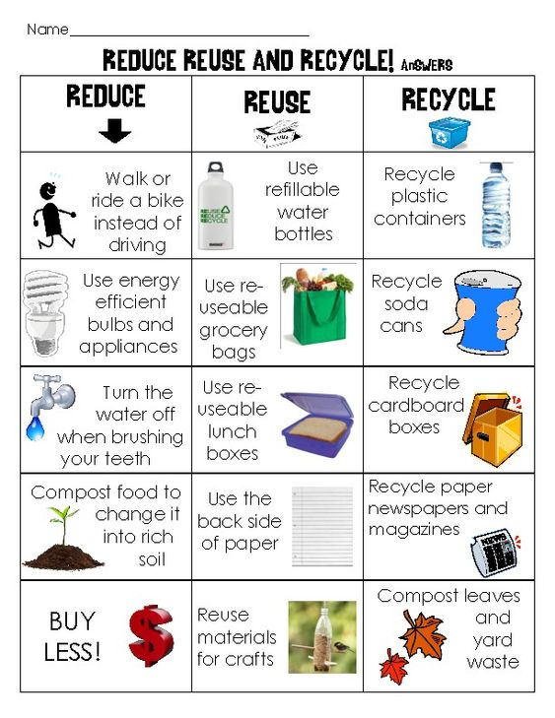

|  |  |  |  |  |  |  |  |  |  |
| --- | --- | --- | --- | --- | --- | --- | --- | --- | --- |
| **Term: I** | | **Level: Fifth Grade** | | | **Unit: 1** | | | **Week:4** | |
| **Domain: Socio-interpersonal** | | | | **Scenario: Go Green** | | **Theme:** 4. Solving Environmental Problems | | | |
| **Enduring Understanding**: Our actions can have a positive or negative chain effect on the environment around us. If we are responsible, we can make the environment better. If we are wasteful, the environment suffers and so do we all. | | | | | | | | | |
| **Essential Question:** How do our actions affect the environment around us? | | | | | | | | | |
| |  | | --- | | **Dimensions** | | **1.** **Ways of thinking ( X  )** | | **2. Ways of living in the world  ( X )** | | **3. Ways of relating with others  (X )** | | **4. Tools for integrating with the world  ( X )** | | | | | | | | | | |
| **Learn to Know** | | | | **Learn to Do** | | **Learn to Be and Live in Community** | | | |
| **Grammar & Sentence Frames**  Modal Should   * We should/shouldn´t ____ * I should/n´t _____.   **Phonemic Awareness**  Segmenting multi-syllabic words into syllables.  (/but/ter/fly/, gar/bage/)  **Vocabulary**  4. Solving Environmental Problems  Problems  Littering, energy misuse, water misuse  Actions  Planting, reusing, recycling  Expressions   * We___ (classify) garbage. * We ___ (plant)trees   We should not waste ____ (water and energy). | | | | **Function**   * Describing ways to solve environmental problems   **Discourse Markers**  Linkers: Sequential - past tense  First, then, after that, finally | | **Psycho-social**   * Developing creativity, collaboration critical thinking and communication skills   **Socio-cultural**   * Taking care of Mother Earth * Conserving the protected areas in our country   **idioms/ phrases**  Out of the woods (out of danger) | | | |
| **Assessment Strategies & Evidences of learning**  (Diagnostic, formative, summative) | **Goals** | | | **Pedagogical Mediation/ Didactic Sequence** | | | | | **Time** |
| Learner… | Learner can | | | **Pre-teaching**  **Routine**: Take attendance in class,  Share the Essential Question on the board and Goal (Can do´s) of the class  **Connecting**  **Warm up**  Learners listen and reflect on the video story What really happens to the plastic you throw away - Emma Bryce <https://www.youtube.com/watch?v=_6xlNyWPpB8&feature=emb_logo>  **Activation of Prior Knowledge**  Teacher use the idiom poster **Out of the woods** to explain the meaning and give an example of sociocultural and social language related with the scenario and theme of this unit.    **Modeling**  Teacher model pronunciation and explain meaning of vocabulary related with What is Climate Change? Video <https://www.youtube.com/watch?v=ko6GNA58YOA&feature=emb_logo>  **Clarification**  **Clarifying**  Teacher shows a picture of the city and ask the following questions  **What can you see in this city? What problems can you see?**  https://files.liveworksheets.com/def_files/2020/10/16/1016010900524653/1016010900524653001.jpg  Learners mention problems like pollution (air and water), trash/ garbage, overpopulation; few green areas, a lot of traffic (vehicles, cars) and teacher clarify pronunciation and meaning of vocabulary. | | | | | 40 minutes |
| **SI.1.** Indicates strengths and weaknesses of personal or human actions on the environment. | **SI.1.** indicate strengths and weaknesses related to the theme and language function. | | | **Pre-task**  **Connecting**  The teacher shares the goal of the lesson.  Learners watch the video about **The environment problems and solutions Logos Academy** <https://www.youtube.com/watch?v=zu2cgoQwnPU> and point out problems that are affecting the environment and some of the possible solutions.  **Clarification**  **Task-rehearsal**  Learners in pairs talk about the environmental problems and actions for solving the problems mention on the video.   |  |  |  |  |  | | --- | --- | --- | --- | --- | | **Student A** | **Student B** | | | | | What is the environment? | All the living things and the characteristics where they live, like temperature, soil and humidity. | | | | | What problems do you identify by looking at the following pictures? | Free Pollution Cliparts, Download Free Clip Art, Free Clip Art on Clipart  Library | https://inhabitat.com/wp-content/blogs.dir/1/files/2013/11/extinct-animals.jpg | | 221 Desertification Illustrations, Royalty-Free Vector Graphics & Clip Art  - iStock | | Pollution | Extinction of animals | | Desertification | | What is the difference between deforestation and desertification? | **Deforestation** Is cutting down of trees and disappearance the forest. | | **Desertification** Is the transformation of some landscape into desert areas. | | | Which are some solutions for the environmental problems? | Environmental Protection Area Signs - Henrico County, Virginia  Protected Natural areas | Introduction - towellm/recyclingReduce the amount of garbage | | Avoid cutting down trees |   **Application/building up**  **Task completion**   |  |  | | --- | --- | | **Environmental problems** | **Action for solving problems** | | water misuse | Vector de stock (libre de regalías) sobre Ilustración de No Desperdiciar  Agua389409085 MyLittleBigThing on Twitter: "#Water sustains life, but too often, for too  many people, it is not safe to drink or readily available. We must learn to  conserve the little quantities of water | | energy misuse |  | | Littering |  |   Learners get the following chart with some other environmental problems.  In pairs, they are going to asked each other and share different actions or solution for each problem, based on the example of videos they watched. . **(Collaboration)**  **Task assessment**  Learners in pairs are going to assess themselves by asking each other the questions on the conversation cards about environmental problems and matching them with the solutions or answers. . **(Collaboration)**   |  |  |  | | --- | --- | --- | | What are 3 environmental problems you can identify? | Which are 3 solutions for the environmental problems? | What are 2 ways to save water? | | What are 3 effects of pollution? | What are 2 solutions for deforestation? | What are 3 tips to save energy? | | Reforestation  Government regulation | Soil  Water  Air | Be a leak detective  Take a short showers | | Pollution  Desertification  Extinction of animals | Recycle  Avoid cutting trees  Protected natural areas | Turn off the lights  Unplug unused electronics  Use natural light | | | | | | 40 minutes |
| **R.PA.1.** Reads words and sentences by decoding English graphemes and phonemes using knowledge of word parts, syllabification and phonemic awareness. | **R.PA. 1.** decode English graphemes and phonemes using knowledge of word parts, syllabification and phonemic awareness. | | | **Connecting**  **Pre-task**  The teacher shares the goal of the lesson.  Learners watch the video about Multisyllabic Word Reading Strategy  <https://www.youtube.com/watch?v=drMJltTnrtM>  Teacher have a list of words for students and ask them to use the following tips for reading multisyllabic words in the list:      **Clarification**  **Task-rehearsal**  Learners applying segmenting multisyllabic words into syllabus with the presentation of Multisyllabic words 1 video <https://www.youtube.com/watch?v=QYNEHD1C99M>  In pairs learners are going to use the same list and will practice segmenting words.  Students can use buttons, bottle caps to represent segmenting multisyllabic words like the example was shown on the presentation in the video. The students put down a counter for each segmenting sound. oral blending and segmenting - phoneme frame    **Application/building up**  **Task completion**  Learners are going to classify multisyllabic words into syllables using the poster when they finish teacher say the word and the whole class have to clap for each syllable of the word. . **(Collaboration)**    **Task assessment**  Students use a drum or tambourine to take turns drumming out the syllables in the word or picture the teacher shows. Example How many beat do you hear in this word?   |  |  | | --- | --- | | Introduction - towellm/recycling  Recycle | **Re cy cle**  **(3)**  **Re cy cle**  **Espacio para el texto** | | | | | | 40 minutes |
| **W.2.** Applies conventions of standard English when writing short texts. | **W.2.** apply conventions of standard English | | | **Connecting**  **Pre-task**  The teacher shares the goal of the lesson. The teacher reviews the use of end punctuation.  Learners watch and listen how the intonation and punctuation change depending if it is a question or answer on the video Environmental Problems | Speaking English Fluently | Common Daily Expressions <https://www.youtube.com/watch?v=Ot_4VSmPQk4>  **Clarification**  **Task-rehearsal**  Learners gets short paragraph without any end punctuation and play the video to apply the end punctuation.   |  | | --- | | Girl: are you worried about our future  Do you care about the environment  Boy: I´m worry about our future And I care about the environment  Girl: what are some of the most serious environmental problems  Boy: Our environment is constantly changing  Some of the most serious environmental problems are pollution, global warming and overpopulation  Girl: Pollution is one of the biggest threats for the environment and affects everyone: animals humans forest and oceans  what is your thought on global warming  where will we get our energy when we run out of oil |   The teacher monitor the learners’ performance and check that they are including capital letters, periods, and question marks.  **Application/building up**  **Task completion**  Learners work individually using the information about environment in the infographic to create at least six sentences.  https://i.pinimg.com/564x/d3/4b/05/d34b0569577032e80cad9dc4d1e05ad9.jpg F:\DPSC 2020\Teletrabajo 2020\Scope and Sequence 5th grade\Materiales y planeamiento Unit 1 Go Green 5th grade week 3 & 4\Materiales Week 3 and 4\6 ways to help the environment infographic.jpg  After the learners complete the task are going to work in pairs to self-assess their sentences. The teacher ask them to check if the punctuation is correct (capital letters, periods). . **(Collaboration)**  **Task assessment**  Learners will write one questions for each sentence. They can follow this example   * What can you do to save water? * I can use a drink bottle to save water.   Finally, share your work with a partner. | | | | | 40 minutes |
| **Integrated Mini-Project**. **(Collaboration)** | | | | | | | | | **Time** |
| **Creating a mini compost bin or bag Project**   * **Planning and creating collaboratively** in the house and community to be conscious about changing actions that affect the environment. Learners create a compost poster as a visual aid and present their compost bin or bag report to the class. They can talk about the definition of compost, green and brown materials, the process and ways to compost. * **Preparing** a presentation**, rehearsing and narrating** how to start composting. * **Participating** in individual assessment. | | | | | | | | |  |
| **Reflective Teaching** | | | | | | | | | |
| What worked well | | | What didn’t work well | | | | How to improve | | |
| **Enduring Understanding Reflection** | | | | | | | | | |
|  | | | | | | | | | |

|  |  |  |  |
| --- | --- | --- | --- |
| **Learner Self-Assessment** | | | |
| ***I can…*** | ***C:\Users\mcastilloh\Downloads\descarga.jpg***  ***No achieved yet*** | ***C:\Users\mcastilloh\Downloads\Grinning-Face-with-Smiling-Eyes.png***  ***In progress*** | ***Resultado de imagen para happy emoji***  ***Achieved*** |
| recognize the meaning of the idiomatic expression **Out of the woods** in a real context or short expression |  |  |  |
| point out strengths and weaknesses of personal or human actions on the environment. |  |  |  |
| segmenting multisyllabic words into syllables. |  |  |  |
| apply conventions of standard English grammar and usage when writing short texts. |  |  |  |
| use capital letter at the beginning of a sentence. |  |  |  |
| write a period at the end of a sentence. |  |  |  |
| use a question mark at the end of a question |  |  |  |

**Idiom of the day**

**Out of the woods**

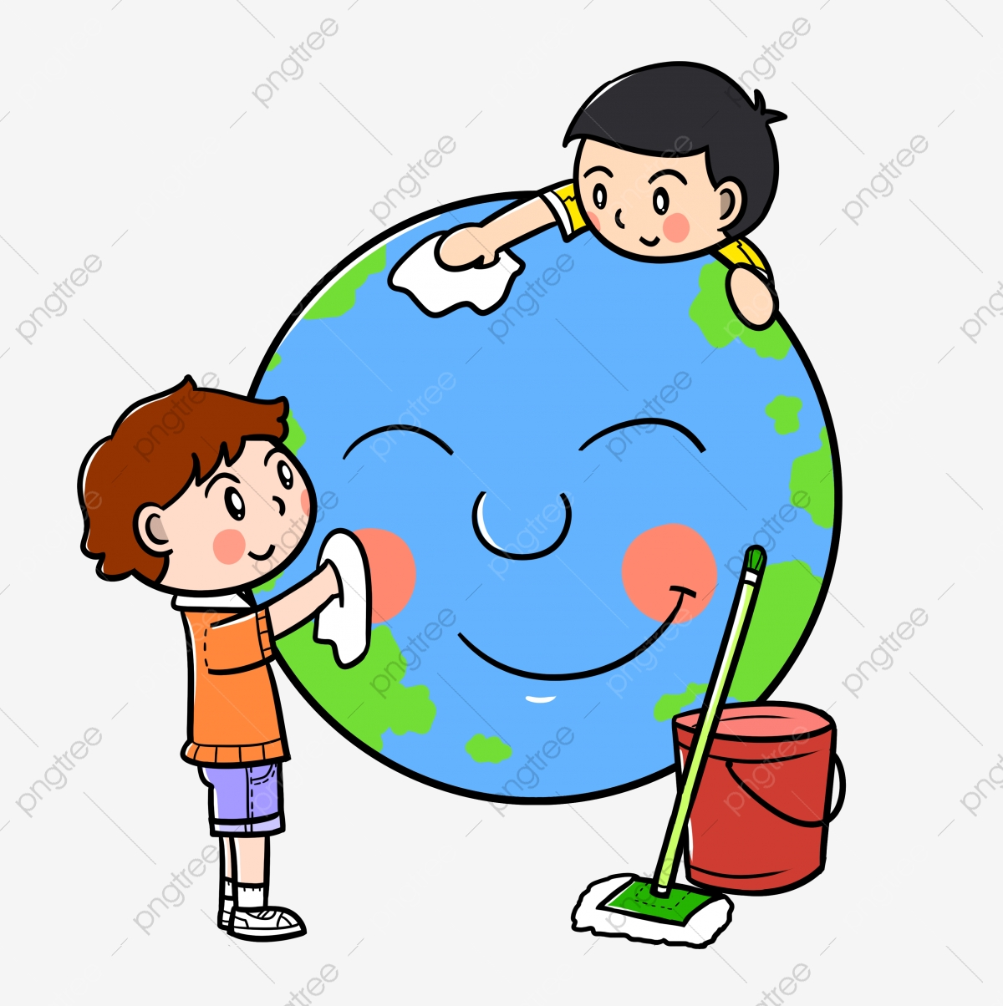

**Meaning**: **out of danger or difficulty; no longer in a**

**dangerous situation.**

**Example**: **Let´s save the Earth because the environment**

**is not out of the woods.**

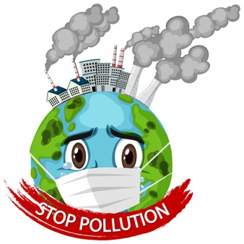

|  |  |  |  |  |
| --- | --- | --- | --- | --- |
| **Multisyllabic word list for Environment** | | | | |
|  | **2 Syllable**  **Words** | **3 Syllable**  **Words** | **4 Syllable**  **Words** | **5 or 6 Syllable**  **Words** |
| 1 | paper | syllable | environment | electricity |
| 2 | garden | dangerous | education | organization |
| 3 | garbage | pollution | temperature | precipitation |
| 4 | water | connection | conversation | deforestation |
| 5 | sunny | recycling | population | communication |
| 6 | planting | littering | thermometer | collaboration |
| 7 | plastic | energy | extinction | classification |
| 8 | reduce | organic | transportation | imagination |
| 9 | forest | habitat | combination | desertification |
| 10 | reuse | opinion | vegetable | reforestation |
| 11 | protect | bicycle | responsible | evaporation |
| 12 | question | solution | information | unforgettable |
| 13 | frozen | government | explanation | overpopulation |
| <https://www.howmanysyllables.com> | | | | |

|  |  |  |
| --- | --- | --- |
| Free Post It Note, Download Free Clip Art, Free Clip Art on Clipart Library  Locate and see if you can identify the vowel graphemes in the word by underlining them. | Free Post It Note, Download Free Clip Art, Free Clip Art on Clipart Library  Box any familiar suffixes. | F:\DPSC 2020\Imagenes\post it orange image.jpg  Circle familiar prefixes. |
| F:\DPSC 2020\Imagenes\post-it yellow image.png  Use a pencil to dig under each syllable, blending left to right. | F:\DPSC 2020\Imagenes\post-it green image.png  Use knowledge of syllables to decode the vowel sounds. | F:\DPSC 2020\Imagenes\post it or sticky blue image.png  Say the whole word and  see if it makes sense.  Check the context for clarification |

|  |  |  |  |  |
| --- | --- | --- | --- | --- |
| **Poster to classify Multisyllabic words in syllables** | | | | |
| Environment, pollution, deforestation, energy, information, water, reforestation, recycling, paper, desertification, garbage, planting, extinction, solution, reduce, littering, conservation, classification, collaboration, temperature | | | | |
|  | **2 Syllables** | **3 Syllables** | **4 Syllables** | **5 or 6 Syllables** |
| 1 |  |  |  |  |
| 2 |  |  |  |  |
| 3 |  |  |  |  |
| 4 |  |  |  |  |
| 5 |  |  |  |  |

|  |
| --- |
| **Dialogue from Environmental Problems Video**  <https://www.youtube.com/watch?v=Ot_4VSmPQk4>  Girl: Are you worried about our future?  Do you care about the environment?  Boy: I´m worry about our future. And I care about the environment.  Girl: What are some of the most serious environmental problems?  Boy: Our environment is constantly changing.  Some of the most serious environmental problems are pollution, global warming and overpopulation.  Girl: Pollution is one of the biggest threats for the environment and affects everyone: animals, humans, forest and oceans.  What is your thought on global warming?  Where will we get our energy when we run out of oil?  Boy: Global Warming refers to the rise in average surface temperatures on Earth.  We have to expand the use of renewable energy.  We have to transform our energy system to one that is less dependent on coal and other fossil fuels.  Will the problems get worse or will they slowly disappear?  Girl: They will never disappear. They only get worse, if we don´t change our lifestyles.  Boy: Do you think houses will be more environmentally friendly in the future?  Girl: I hope they will be environmentally friendly. Otherwise, our future will be dark.  We have to drive hybrids cars.  Boy: We should do whatever we can to prevent pollution and global warming. |

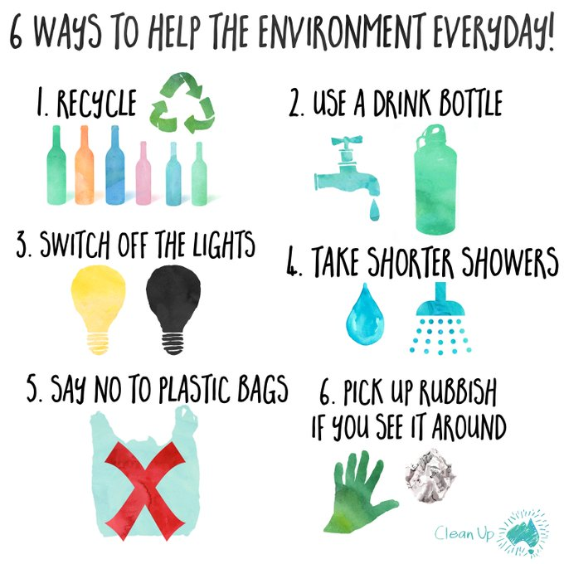

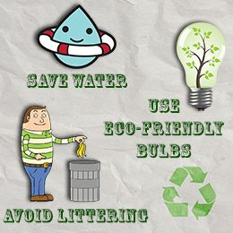

**Links for materials**

Links week 1

**Week 1**

# The original rainforest rap with lyrics

<https://www.youtube.com/watch?v=ZOgApjGFmnU>

# Anthem for the Amazon- Lyric Video

<https://www.youtube.com/watch?v=ZKumZJPClec>

Anthem for the amazon lyrics

<https://amazonaid.org/anthem-for-the-amazon/>

# Rainforests 101 | National Geographic

<https://www.youtube.com/watch?v=3vijLre760w>

# Phonics Word RAP | Long Vowel i (CVCe) | Phonics Monster

<https://www.youtube.com/watch?v=d7o61e_8OEY>

# Phonics Lesson | Long Vowel i (CVCe) | Phonics Monster

<https://www.youtube.com/watch?v=yCnTJd2O9So&list=PLDrTATEEK78zX9u2x4j8Gomevfg7km5wc>

Links week 2

# Environment vocabulary – Word search puzzle in English

<https://www.english-learn-online.com/>

Words with the long I sound

<https://www.enchantedlearning.com/phonics/mc/i-long/worksheet.png>

### Phonics Flashcards (Long I Vowel)

<https://www.google.com/url?sa=i&url=https%3A%2F%2Fwww.englishforkidz.com%2F2015%2F03%2Fphonics-flashcards-long-i-vowel.html&psig=AOvVaw04fpB1Msrj0rv22axe6FnP&ust=1612042046354000&source=images&cd=vfe&ved=0CAIQjRxqFwoTCKj34e2Kwu4CFQAAAAAdAAAAABAE>

Long vowel I Bingo

<https://encrypted-tbn0.gstatic.com/images?q=tbn:ANd9GcQG9gEafHbvBuc_0_CdOXIRZWICyTDd5RowzQ&usqp=CAU>

Worksheet for long vowel /ei/

<https://blog.maketaketeach.com/wp-content/uploads/2012/05/4-In-A-Row-Magic-e-Freebie1.gif>

Long /a/ sound activity

<https://i.pinimg.com/originals/1e/25/06/1e25060063511fab07b05cd533896bbc.jpg>

Read and draw activity

<https://i.pinimg.com/originals/1b/9a/9d/1b9a9d7c50bbfc2c6435d8eea39f7064.jpg>

Write the word

<https://i.pinimg.com/originals/66/ee/42/66ee42806eddf0e0690f913a275b3d7e.jpg>

Videos

Ten simple steps to save our environment

<https://www.youtube.com/watch?v=YND_rYGLwzE>

# Long vowel pair AY Sound Song l Phonics for English Education

<https://www.youtube.com/watch?v=PHkBMNJhK8I>

# AI , A - E and AY | Similar Sounds | Sounds Alike | How to Read | Made by Kids vs Phonics

<https://www.youtube.com/watch?v=ghd898RDjEM>

# Phonics ai and ay words. Sounds Great 5: Unit 1

<https://www.youtube.com/watch?v=2vjYnPUIdpo>

# 15 Words - About the Environment

<https://www.youtube.com/watch?v=zo_6cKHS4dk>

# 10 Major Current Environmental Problems

<https://www.youtube.com/watch?v=A0pB1qw8SMs>

How to take care of the environment 10 ways to take care of the environment

<https://www.youtube.com/watch?v=X2YgM1Zw4_E>

Sarah Hyland Wants You to Protect Our Planet – Now You Know

<https://www.youtube.com/watch?v=8olvMsyQDWc>

Greenhouse Effect video for Kids | The Greenhouse Effect

<https://www.youtube.com/watch?v=DYHAZaasdxI>

Greenhouse Effect | [#aumsum](https://www.youtube.com/results?search_query=%23aumsum) [#kids](https://www.youtube.com/results?search_query=%23kids) [#science](https://www.youtube.com/results?search_query=%23science) [#education](https://www.youtube.com/results?search_query=%23education) [#children](https://www.youtube.com/results?search_query=%23children)

<https://www.youtube.com/watch?v=x_sJzVe9P_8&feature=emb_logo>

Reduce, Reuse and Recycle, to enjoy a better life | Educational Video for Kids.

<https://www.youtube.com/watch?v=OasbYWF4_S8>

THE EARTH BOOK by Todd Parr

<https://www.youtube.com/watch?v=lpEc5nHqO2c>

Michael Jackson - Earth Song. (Lyrics)

<https://www.youtube.com/watch?v=OstvvP8QuxQ>

Recycle Rally -- How to Set Up and Play This Board Game by Adventerra Games North America

<https://www.youtube.com/watch?v=qwHImaQSmko>

Let’s Play “RECYCLE RALLY”

<https://www.youtube.com/watch?v=kGohwgWwsHk>

Human Impact | Environment Biology

<https://www.youtube.com/watch?v=Um-bo2MWDsQ>

Human Impacts on the Environment

<https://www.youtube.com/watch?v=IKZMGBA_0Ik>

8 Ways Kids Can Help the Environment

<https://www.youtube.com/watch?v=vONBU7btYuo>

5 Incredibly Fun GAMES to Teach Self-Regulation (Self-Control) | Early Childhood Development

<https://www.youtube.com/watch?v=H_O1brYwdSY>

Teaching Self-Regulation by Modeling

<https://www.youtube.com/watch?v=UD9m5n-ZpB0>

Habilidades de autorregulación: ¿por qué son cruciales?

<https://www.youtube.com/watch?app=desktop&v=O5-hFF3nri8>

Autorregulación de emociones

<https://www.youtube.com/watch?v=3HJIsyQdQlM>

Mabra - La autorregulación video

<https://www.youtube.com/watch?v=cPpDUoUS33Y>

TÉCNICA DE LA TORTUGA - AUTORREGULACIÓN PARA NIÑOS

<https://www.youtube.com/watch?v=9hHCqnkyjqg>

Decode Multi-Syllable Long Words Song

<https://www.youtube.com/watch?v=4qe5SJf5jGg>

Syllables! | Scratch Garden (segmenting)

<https://www.youtube.com/watch?v=9S7DY2lgJlU>

Multisyllabic Word Reading Strategy

<https://www.youtube.com/watch?v=drMJltTnrtM>

My favorite multisyllabic Word activities

<https://www.youtube.com/watch?v=uFEsFsqcajw&feature=emb_logo>

Multisyllabic words 1

<https://www.youtube.com/watch?v=QYNEHD1C99M>

Multi-Syllable Words: Part 1 of 2

<https://www.youtube.com/watch?v=DEYGgcoCwl8>

Multi-Syllable Words: Part 2 of 2

<https://www.youtube.com/watch?v=7HHSk7nyk_0>

Spot & Dot Decoding Strategy

<https://www.youtube.com/watch?v=yc3ZE6_GU9s>

**Créditos**

**Dirección de Desarrollo Curricular**

**Créditos**

**Dirección de Desarrollo Curricular**

**Departamento de Primero y Segundo Ciclos**

**Jefatura: Richard Navarro Garro**

**Elaboración:**

Ana Isabel Campos Centeno y

Yaudy Ramírez Vásquez,

Asesoras nacionales de Inglés del Departamento de Primero y Segundo Ciclos

**Portada**

Marco Brenes López, Diseñador Gráfico  
Dirección de Recursos Tecnológicos, GESPRO